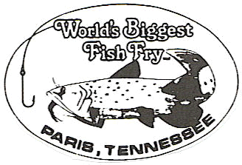
SPONSORED BY:
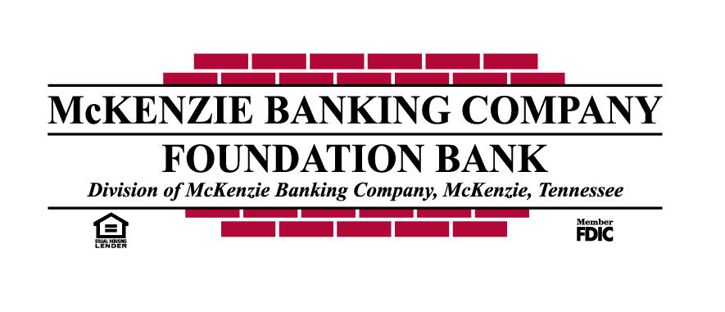 SMALL FRY PARADE
APRIL 27th, 2024 @ 10 AM
ENTRY FEE $5 PER CATEGORY
**FEE MUST BE PAID AT THE TIME ENTRY IS SUBMITTED**
**DEADLINE TO ENTER IS APRIL 23rd, 2024 @ 5 PM**
**Entries are to be turned in at WBFF Headquarters**
Name _____________________________________ Age _____

Parent/Guardian ________________________ Phone _________

Street Address ________________________________________

City State Zip _________________________________________

__________ BEST DECORATED BICYCLE / TRICYCLE ________ BEST DECORATED POWERWHEELS

__________ BEST CHARACTER / COSTUME ________ BEST GROUP THEME POWERWHEELS

__________ MOST ORIGINAL FLOAT ________BEST CHARACTER/COSTUME POWERWHEELS

__________ BEST DECORATED FLOAT ________MOST ORIGINAL POWERWHEELS

__________ BEST MARCHING UNIT

__________ COOLEST PET
___________________________________________________________
**YOU MUST BRING A COPY OF THIS ENTRY TO PARADE LINEUP**
- NO MOTORIZED VEHICLES OF ANY KIND.
- PETS MUST BE ON A LEASH & UNDER CONTROL AT ALL TIMES.
- CHECK IN BEGINS AT 9AM IN THE BUS PARKING LOT AT BARTON FIELD BETWEEN MCADOO AND DUDLEY ST
- NO OBJECTS (candy, gum, etc.) THROWN TO THE SPECTATORS! THESE ITEMS MAY BE HANDED OUT ONLY AT THE SIDELINES! YOUR ENTRY WILL BE PULLED OUT OF THE PARADE IF ITEMS ARE THROWN.
- All applicants must be 12 years old and under.
- We reserve the right to refuse any entries.
- POWERWHEELS RULES
- Any regular electric standard size Power Wheels vehicle is allowed.
- Kids 3-10 years can participate.
- Helmets must be worn (bicycle helmet, etc)
- The vehicle is allowed to have a Stock style 6- or 12- volt battery. (No battery or motor modifications allowed.
- All children must be accompanied by a parent or guardian along the parade route.
- All children must be able to maintain complete control of the vehicle or have a remote control that operated the vehicle.
BY COMPLETING AND SUBMITTING THESE APPLICATIONS, I/WE DO HEREBY, FOR MYSELF, MY HEIRS, EXECUTORS AND ADMINISTRATORS, DO WAIVE AND RELEASE ANY AND ALL RIGHTS AND CLAIMS FOR ANY DAMAGES AND/OR INJURIES INCLUDING POWERWHEELS INCIDENTS I/WE MAY HAVE AGAINST THE CITY OF PARIS, HENRY COUNTY, OFFICIALS OF THE WORLD'S BIGGEST FISH FRY, THE WORLD'S BIGGEST FISH FRY OR ANY GROUP OR PERSON INVOLVED WITH THE WORLD'S BIGGEST FISH FRY.

