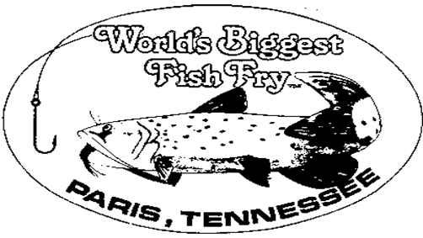
2024 World’s Biggest Fish Fry
Car & Bike Show
April 20th, 2024

Owner/Participant: _________________ Email: __________________
City: _________ State: ________
Year: ________ Make: ___________
Model: __________ Color: __________ Modified: yes/no
Club Affiliation: _____________________________
Miles Traveled: _____________

I assume all risk of bodily injury, property damage, and personal damage that may occur by participating in the 2024 World’s Biggest Fish Fry Car Show/Cruise In and, for myself/ourselves, their heirs, executors, and administrators, do hereby forever waive and release any and all claims against and agree to hold harmless the 2024 World’s Biggest Fish Fry, KPAC, Paris Elementary School, their committees, sponsors and volunteers, Paris-Henry County Jaycees, Worlds Biggest Fish Fry Inc., and successors or assigns any kind from any and all claims which may be made for any cause whatsoever arising as a result of participation.
Further, I hereby consent to allow my picture(s) or likeness to appear in any official document, news release, sponsor advertisement, and/or television and radio coverage of the events within or as part of the 2024 World’s Biggest Fish Fry Car Show/Cruise In and grant permission to use and/or publish photographic portraits or pictures, video tape, or film of me in which I may be included in whole, part, composite, or reproductions thereof in black and white and/or color or otherwise made through any media now known for art, advertising, trade, or any other similar lawful purposes whatsoever, including the publicity and promotion of this event itself, excluding commercial use of or by marketing professionals.

Signature of applicant: Date:
___________________________________ __________________________
Signature of applicant Date

